ASSIGNMENT-1

FUNDAMENTALS OF LINUX COMMANDS

1. Which command is used to know the current working directory?

A:pwd stands for "print working directory." When you run this command, it displays the full path of the current directory you're working in.

1. How would you find out its contents?

A: The ls command lists the files and directories in the current directory. To view detailed information like file sizes, permissions, etc., you can use options like ls -l.

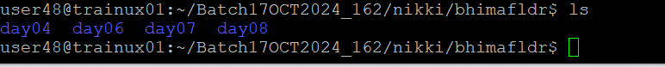

1. Identify the commands with inputs to do the following
   1. create a directory d1

A:mkdir d1



* 1. create a subdirectory d2 in d1

A:mkdir d1/d2

* 1. change to directory d2

A:cd d1/d2

* 1. create an empty file “f1.txt”

A:touch f1.txt

* 1. display the contents of “f1.txt”

A:cat f1.txt

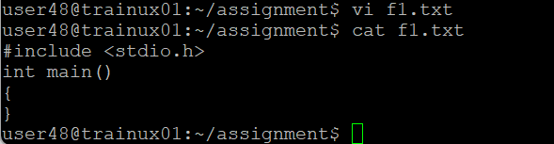

* 1. view the contents of d1 from current directory d2

A:ls ../

1. Use the ls command with its options. How will you identify directories from the listing?

A:ls -l

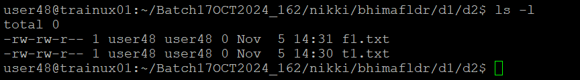

1. Use ls to do the following
   1. List files with single character names.

A:ls

* 1. List hidden files also. [ Note : Hidden files are files having name started with a “.” ]

A:ls-a

* 1. Suppose there are files tb1.1, tb2.1, tb3.1, ….tb10.1. Write command to list all the files [Hint: use wild card characters]

A: ls tb*.1

1. Write the command to list all files in descending order of their size.

A:ls -lS

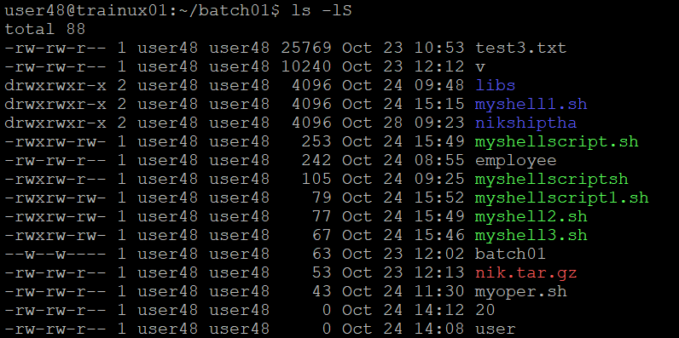

1. Suppose there are files temp1, temp2, temp3. Write command to remove the files without listing them explicitly

A:rm temp*

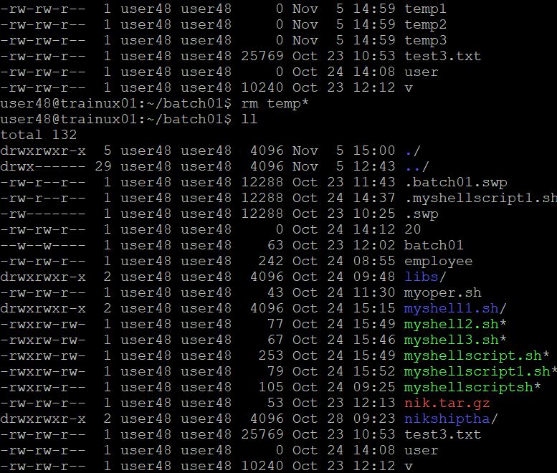

1. Which command is used to list top few lines in the file?

A:head -n 5 filename

1. Create a directory “testdir”

A:mkdir testdir

1. Use cp command to do the following
   1. Copy the file tb1.1 (created above) in the same directory.

A: cp tb1.1 tb1.1.copy

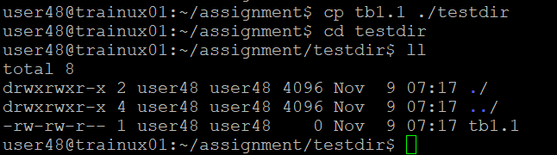

* 1. Write a command to copy all the files i.e tb1.1,tb2.1,tb3.1,…..tb10.1 in a new directory –“new”

A: cp tb*.1 new/

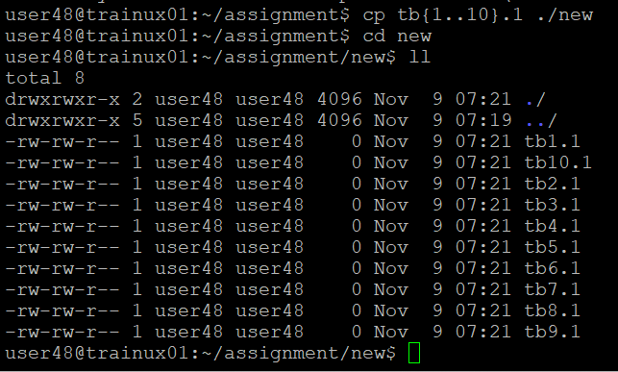

* 1. Create a subdirectory in new in named“new1”.

A: mkdir new/new1

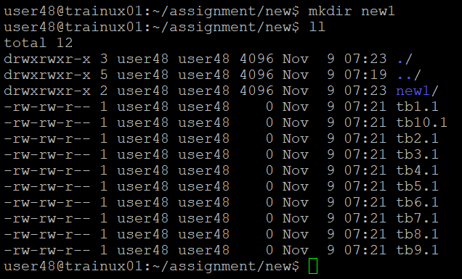

* 1. Write a command to copy selectively only tb2.1, tb6.1, tb7.1 and tb10.1 in the directory new1.

A: cp tb2.1 tb6.1 tb7.1 tb10.1 new/new1/

* 1. Write a command to copy the entire directory “new” to a directory “newprogs”. [Note : use the –R option of “cp” command ]

A: cp -R new/ newprogs/

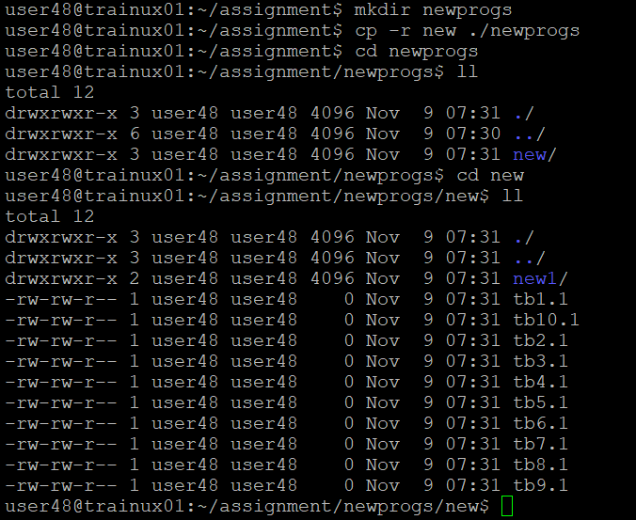

1. Find out the difference between
   1. ]“mv” & “cp”

A: mv **moves** or **renames** files/directories (removes from original location), while cp **copies** files/directories (leaves original intact).

* 1. “rm”, “rmdir”

A: rm **removes files and directories** (including non-empty ones with -r), while rmdir only removes **empty directories**.

* 1. “mkdir” and “mkdir -p”

A: mkdir creates a directory **if its parent exists**, while mkdir -p creates **parent directories as needed** and does not throw an error if the directory already exists.

1. Use a single command rmdir once to remove “testdir” and all its sub directories and files created above.

A: rmdir testdir

rm -r testdir

1. Which command is used to get the manual information of a command?

A: man <command>

1. If you are not able to change to a directory what could be the likely cause?

A:Possible Causes:

* + Non-existent directory: The directory may not exist.
  + Permission issues: You may not have the necessary read or execute permissions to access the directory.
  + Typo in the directory name: You might have mistyped the directory name.
  + Full disk or file system errors: The disk or file system may be full or corrupted.

1. Explain the differences among the following commands:  
                 a. cd /

A: Changes the current directory to the **root directory** (/), which is the top-level directory in the filesystem.

  b. cd ..

A: Moves the current directory **one level up** to the parent directory of the current working directory.

  c. cd

A: Changes the current directory to the **user's home directory**.

  d. cd ../..

A: Moves the current directory **two levels up** to the grandparent directory.